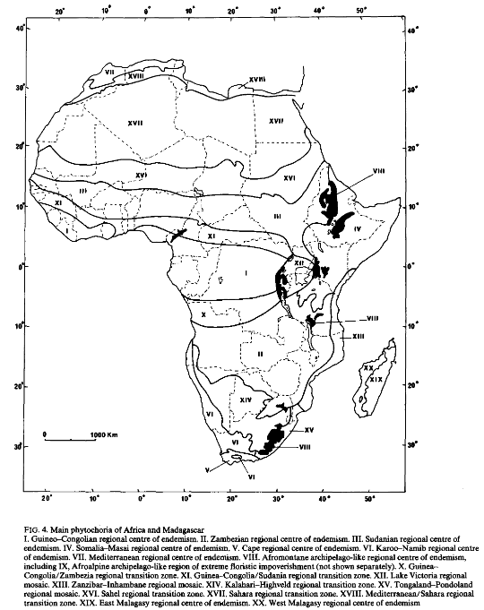

1. Guineo-Congolian regional centre of endemism.
2. Zambezian regional centre of endemism.
3. Sudanian regional centre of endemism.
4. Somalia-Masai regional centre of endemism.
5. Cape regional centre of endemism.
6. Karoo-Namib regional centre of endemism.
7. Mediterranean regional centre of endemism.
8. Afromontane archipelago-like regional centre of endemism, including
9. Afroalpine archipelago-like region of extreme floristic impoverishment (not shown separately).
10. GuineaCongolia/Zambezia regional transition zone.
11. Guinea-Congolia/Sudania regional transition zone.
12. Lake Victoria regional mosaic.
13. Zanzibar-Inhambane regional mosaic.
14. Kalahari-Highveld regional transition zone.
15. Tongaland-Pondoland regional mosaic.
16. Sahel regional transition zone.
17. Sahara regional transition zone.
18. Mediterranean/Sahara regional transition zone.
19. East Malagasy regional centre of endemism.
20. West Malagasy regional centre of endemism